

The top three options are for the Chief EMS Officer who is the individual with overall mandated responsibility that focuses on EMS as their primary task.

The next three options are for the subordinate Chief EMS Officer. with a minimum of 10 years emergency medical services field or system experience as an Emergency Medical Technician, Paramedic, Registered Nurse, Advanced Registered Nurse Practitioner, or Physician.



Points:

Points:

Check the degree or academic certificate you have earned. Only one box may be checked here.

List total points earned…if 150 or more you are you are eligible to continue.

Check the appropriate box(es) for additional designations held from CPC.

Check the appropriate box for your department’s workforce for complexity points.

Based on the levels in the chart above, calculate your length of service points. You can use more than one level to achieve up to 30 points.

 

Check appropriately if you completed the National Fire Academy courses listed.

Total Points:

Points:

Points:

Points:

Points:



Include ALL personal information requested.

Include ALL employment information requested. Your immediate supervisor listed here will sign the demographics page and submit a letter of reference.

Be sure to check which mailing address is your preference.

General demographic information about the Department you are currently working with.



Three letters of reference are required:

* 1 from a medical director or physician.
* 2 from a people that know you well in a professional, personal, or volunteer capacity.

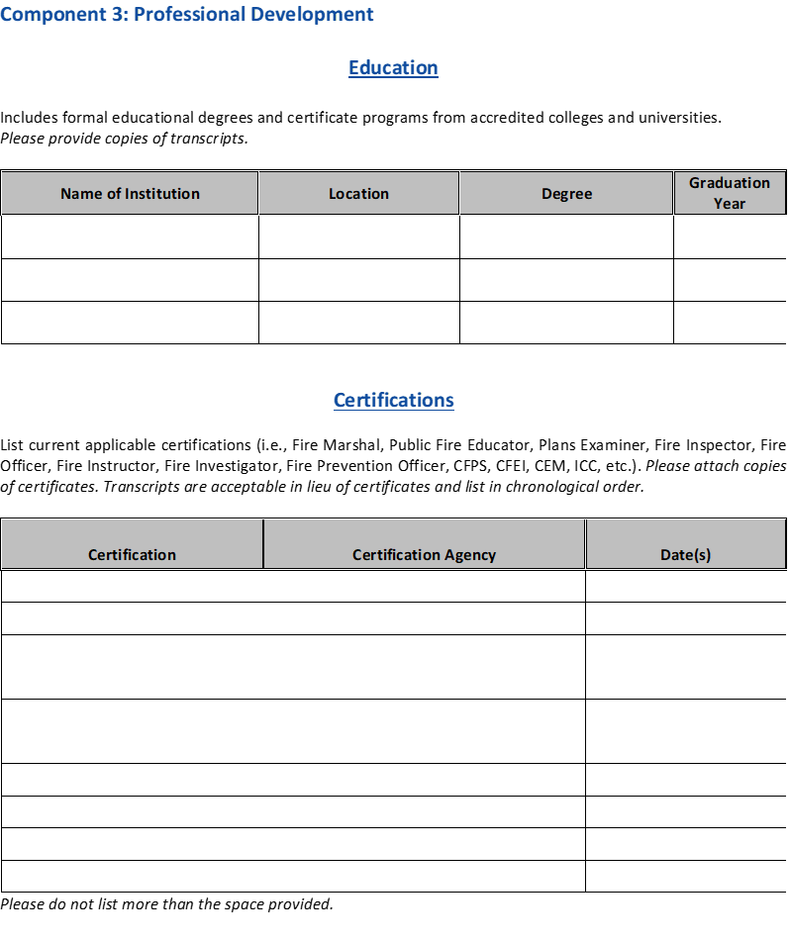

* List all applicable certifications: e.g. Fire Officer, Firefighter, Fire Instructor, EMT
* Attach certificate copy or transcript.
* List only current certifications.
* Do not use more spaces than provided in the application.
* Must be in chronological order.
* List all degree and certificate programs.
* Attach copies of transcripts.
* Degrees must be from accredited colleges.



* List training courses, CEU programs, conferences attended during the past 5 years. Possible course topics includes: business management, human resources, in-house programs, CPSE Excellence Conference.
* Certificates/transcripts not required.
* **List chronologically** (earliest to newest).
* Do not include college course used to actively attain a degree.
* Do not use more spaces than provided in the application.

* Articulate a plan of action for where you want to take your career in the next 3 years. Include such items as:
  + Future training, certification, degrees
  + Community involvement.
  + Association memberships
* Acceptable to highlight achievements but should be mostly future goals.
* Should be in paragraph format.
* Include how you will address the Firefighter Life Safety Initiatives listed.





* List all teaching, public speaking, research published or un-published (i.e. EFO paper), professional articles, and other contributions, during the past 5 years.
* These contributions can be at any level: local, state, regional, national.
* List recognitions received in the last 5 years (e.g. commendations, citizen of the year, service club recognition).
* **List chronologically** (earliest to newest).
* Do not use more spaces than provided in the application.



* List all applicable involvement with community and charitable organizations e.g. Lions Club, Scouting, American Legion, Red Cross, United Way.
* Note what level of involvement: chair, officer, member, worker.
* Note hours of involvement over which time period (e.g. 2 hours per month)
* Not required to fill all spaces.
* Do not use more spaces than provided on the application.
* List all applicable organizations you have been involved with e.g. IAFC, IAFF, NFPA, Local Fire Chiefs, Local Emergency management group.
* Note what level of involvement: member, board member, officer
* Not required to fill all spaces.
* Do not use more spaces than provided on the application.

ONLY REQUIRED FOR CATEGORY-B APPLICATIONS



Learning content outlines the knowledge, skills and abilities related to the competency.

* Each competency includes learning content and Job Performance Requirement (JPR) from a corresponding NFPA standard.
* Candidates are required to address both education and experience sections under each technical competency.
* Education:
  + List up to seven courses/training classes you have participated in that corresponds to the competency.
  + List should include (in preferred priority order): college level courses, National Fire Academy courses, certification courses, special seminars, or conferences.
  + It is not required to fill all the spaces.
  + Do not use more spaces than the application provides.
* Experience:
  + Provide a narrative that addresses relevant experience to the competency.
  + Include present and prior work experience.
  + Current examples preferred, include major projects completed during your career.
  + The technical competency should be written in paragraph format, with no minimum length requirement. Must sufficiently cover the requirements.
  + Two paragraphs is a good rule of thumb…not a requirement.
  + This is a professional designation so spelling and grammar are extremely important.
* Resources
  + [CPSE University: Credentialing Resources](https://university.cpse.org/Credentialing)

SUBMIT 1 PDF DOCUMENT, ASSEMBLED AS DESCRIBED IN THE PORTFOLIO INSTRUCTIONS

* Attestation statement completed and signed by an individual(s) who can verify the experience outlined for each competency.
* Multiple attestation statements can be used if using more than one individual to attest their experience.
* Optional: Provide additional information that should be considered in the evaluation of the application for designation.
* All candidates must sign and date the certification statement attesting to all statements made in the application are true and completed to the best of your knowledge and also that you read and understand the Code of Professional Conduct and agree to abide by this code.
* Electronic signatures are acceptable.



Copyright © 2020 by the Center for Public Safety Excellence®, Inc., Chantilly, Virginia. All rights reserved.